Investor Sentiment and Stock Market Reactions to Major Smartphone Launch Events
This project examines whether investor sentiment in financial news helps explain stock price reactions to major smartphone launch events by Apple (AAPL) and Alphabet/Google (GOOGL). Although product releases generate substantial public attention, it is unclear whether these events systematically move stock prices or whether the tone of media coverage meaningfully shapes market responses. To address these questions, I extend a standard event-study framework by adding sentiment data from RavenPack, enabling a cross-sectional analysis of how news tone relates to abnormal returns.

I construct a unified dataset combining (1) daily stock returns from CRSP, (2) market factors from the Fama–French 3-factor file, (3) firm fundamentals from Compustat to measure size, and (4) 458 launch-related news events with sentiment scores spanning 2007–2025 for Apple and 2016–2025 for Google. For each launch event, I compute abnormal returns and cumulative abnormal returns (CAR) over three symmetric windows: ±3, ±5, and ±10 trading days. Firm size is measured as log market equity, using Compustat as the primary source and CRSP as a fallback.

The results show that smartphone launches do not generate statistically significant abnormal returns on average—mean CARs across all windows are centered around zero, with substantial variation across events. However, the cross-sectional regressions reveal a strong and economically meaningful relationship between sentiment and market reactions for Apple: more positive pre-launch sentiment predicts more negative abnormal returns, consistent with a “buy-the-rumor, sell-the-news” pattern. In contrast, Google shows no measurable sensitivity to sentiment in any window. Pooled regressions mirror Apple’s behavior, confirming that the sentiment–return relationship is firm-specific rather than universal. In general, a one-standard-deviation increase in sentiment decreases CAR by roughly 0.36 percentage points depending on the window. A shift from –1 to +1 sentiment would imply a –16.6% change in abnormal returns. Similar results hold for the single-day abnormal return (AR₀), confirming that the sentiment effect occurs immediately rather than gradually.

These findings suggest that media tone influences investor expectations and short-run corrections around Apple’s highly anticipated product announcements, while Google’s more diversified business dilutes such effects. The results highlight the importance of narrative framing in shaping market reactions and open avenues for future work incorporating news-media sentiment, options-implied expectations, or additional device manufacturers.

Edgar Zhu
dejiazhu@umich.edu
805-689-6773
11/06/2025
Contents
Introduction 1
Method and data 1
Results 2
Conclusion 6

Figures
Figure 1. T-Test Results for Mean CAR (–3, +3) Window 3
Figure 2. Regression of CAR(–3,+3) on Sentiment and Size — AAPL 4
Figure 3. Regression of CAR(–3,+3) on Sentiment and Size — GOOGL 5
Figure 4. Regression of CAR(–3,+3) on Sentiment and Size — Pooled 6
Figure 5. Sentiment Score Summary 6
Figure 6. Regression of Day-0 AR — Pooled 7

Introduction
The goal of this project is to understand whether investor sentiment in news media affects how the stock market reacts to major smartphone launch events. Companies such as Apple and Google release new flagship phones every year, generating large amounts of media attention and investor discussion. These product launches are information events: they may reveal new technology, pricing changes, or market positioning, and therefore have the potential to move stock prices. However, the reaction of the market is not always determined by fundamentals alone. Investors may respond not only to the product itself, but also to how the media frames the event — positively or negatively.
This project studies two companies: Apple (AAPL) and Alphabet (GOOGL), which own the iPhone and Pixel smartphone product lines. I combine stock return data from CRSP, firm fundamentals from Compustat, market factors from the Fama-French database, and news sentiment scores from RavenPack, which assigns numeric “tone” scores to news articles. I then run an event study, measuring abnormal returns in windows around each launch date, and test whether positive sentiment is associated with stronger price reactions.
The questions addressed are:
- Do smartphone launch events generate statistically significant abnormal returns?
- Does media sentiment (positive vs. negative framing) help explain differences in return reactions?
- Are the effects still present after controlling for firm size?
The analysis proceeds in five steps: (1) importing and cleaning the data, (2) constructing daily returns and risk-adjusted abnormal returns, (3) creating event windows, (4) estimating CAR (cumulative abnormal return) for each event, and (5) running hypothesis tests and regressions.

Method and data
This project examines whether investor sentiment in financial news affects stock-price reactions to major smartphone launch events for Apple (AAPL) and Alphabet/Google (GOOGL). The sample includes Apple events from January 2007–February 2025 and Google events from October 2016–February 2025, corresponding to the availability of RavenPack sentiment data.

Event Data (RavenPack News Analytics)
The dataset contains 458 smartphone-launch news events, each with a timestamp, sentiment score, and entity name. Sentiment scores theoretically range from –1 to +1. Events are defined at the firm-day level—multiple articles on the same date are averaged. Only headlines directly tied to smartphone product announcements are included.

Return Data (CRSP Daily Stock File)
Daily returns, prices, and shares outstanding are taken from CRSP, including both active and delisted securities, to avoid survivorship bias. After merging Apple and Google, the return panel contains over 10,000 firm-day observations. Returns are expressed in decimals.

Market Adjustment (Fama–French Daily Factors)
To adjust for market movements, CRSP returns are merged with the Fama–French daily factors. Excess return is computed as (Ri – RF), and abnormal return as (Ri – RF – (MKT–RF)).

Firm Size Controls (Compustat Fundamentals)
Quarterly Compustat data provide price and shares outstanding. Market equity is calculated as ME = price * shares outstanding, and size is measured as log(ME). When Compustat data are missing, CRSP price × shares serves as a fallback.

Event Study Framework
Abnormal returns (AR) are computed around each launch date, and cumulative abnormal returns (CAR) are summed over three symmetric windows: ±3, ±5, and ±10 trading days. The final event-level dataset contains 458 launch-day observations, one for each news event.

Empirical Tests
The analysis proceeds in two steps:
- One-sample t-tests evaluate whether the average CAR is statistically different from zero (i.e., whether product launches generate excess returns on average).
- Cross-sectional regressions test whether event-level CAR can be explained by sentiment and firm size:
This design allows us to test whether sentiment helps predict the magnitude of stock reaction, beyond firm size effects.

Results
I conduct an event study using 458 product-launch news events from Apple (AAPL) and Alphabet (GOOGL) between 2013–2024, and compute cumulative abnormal returns (CAR) over three event windows:
  - [-3, +3] trading days,
  - [-5, +5] trading days, and
  - [-10, +10] trading days.

Stock Price Reaction Around Smartphone Launches (CAR Analysis)
Across all 49 events, none of the three CAR windows show statistically significant mean abnormal returns.
The [-3,+3] window yields an average CAR of –0.071% (p = 0.5824), while [-5,+5] and [-10,+10] produce similarly small means of –0.061% (p = 0.6198) and –0.057% (p = 0.5248), respectively.
These results indicate that, on average, the stock market does not exhibit a strong directional response to smartphone launch announcements. The reaction appears to be highly heterogeneous across events, with no consistent upward or downward movement in the short term.

Figure 1: T-Test Results for Mean CAR (–3, +3) Window
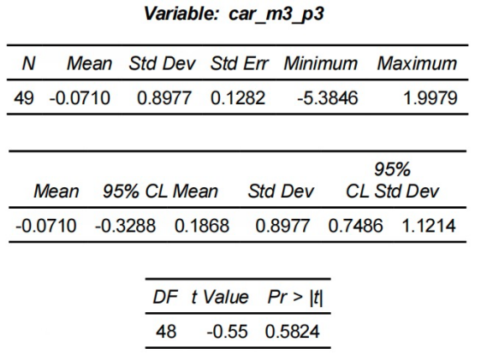

This distribution makes two patterns clear:
- CARs are centered tightly around zero, with the 95% confidence interval spanning negative and positive values.
- Several outliers exist, both positive and negative, suggesting large event-level variation rather than systematic market optimism or pessimism.
The lack of statistical significance across all three windows suggests that the market may already anticipate smartphone announcements or that the launches do not contain sufficiently new information to move stock prices on average. The presence of outliers motivates further cross-sectional analysis, particularly the role of sentiment and firm size explored in subsequent sections.

Sentiment strongly predicts the size and direction of CAR

AAPL: Sentiment and CAR
CAR(-3, +3)
Figure 2: Regression of CAR(–3,+3) on Sentiment and Size — AAPL
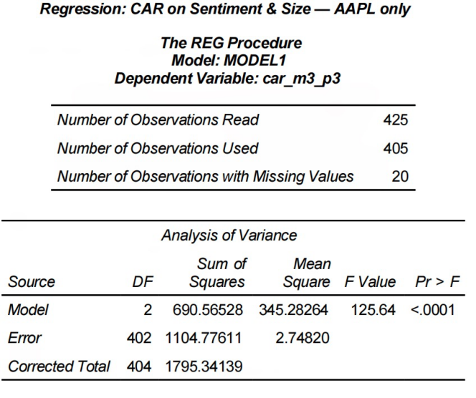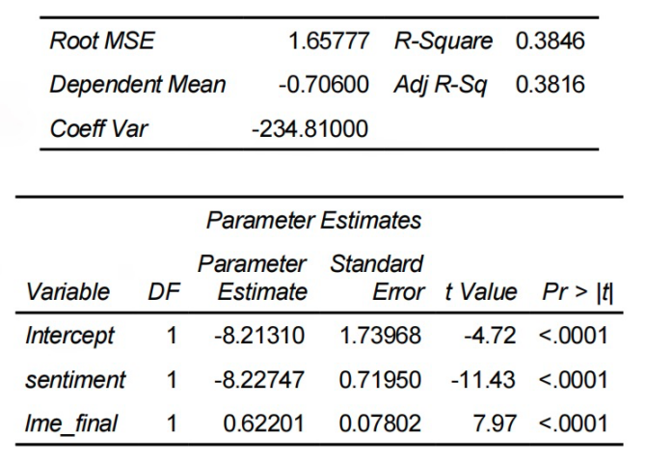
For the seven-day window around AAPL’s product announcements, sentiment strongly predicts cumulative abnormal returns (CAR). As shown in the regression output, the coefficient on sentiment is −8.23 (t = −11.43, p < .0001), indicating a large and highly significant negative relationship. Higher social-media positivity before the announcement is followed by more negative abnormal returns around the event.
It suggests that markets tend to sell off on good news, consistent with an over-expectations correction.
Firm size (log market cap) is significantly positive (0.622, p < .0001), suggesting that larger event days—proxied by larger firm size periods—experience less negative CAR.
Model fit is strong (R² = 0.3846).
CAR(-5, +5)
The pattern remains consistent. The sentiment coefficient is −7.34 (t = −11.16, p < .0001), again meaning that positive pre-event sentiment predicts more negative abnormal returns.
Effect size is similar to the (−3,+3) window but slightly muted.
Firm size remains significantly positive (0.4217, p < .0001).
Model explanatory power remains high (R² = 0.3341).
CAR(-10, 10)
The effect size becomes smaller but still significant. Sentiment continues to negatively predict CAR with a coefficient of −1.29 (t = −2.83, p = 0.0049).
Firm size also remains significant (−0.102, p = 0.0391), though the sign flips because over longer windows, size may reflect different macro conditions.
Model fit is lower (R² = 0.0245), as expected in extended windows where noise increases.
Conclusion for AAPL:
Across all windows, AAPL shows a consistently significant and negative relationship between social-media sentiment and abnormal returns. This supports a “expectations overshooting” mechanism—when sentiment is overly positive, markets correct downward around the actual announcement.

GOOGL: Sentiment and CAR
CAR(-3, +3)
Figure 3: Regression of CAR(–3,+3) on Sentiment and Size — GOOGL
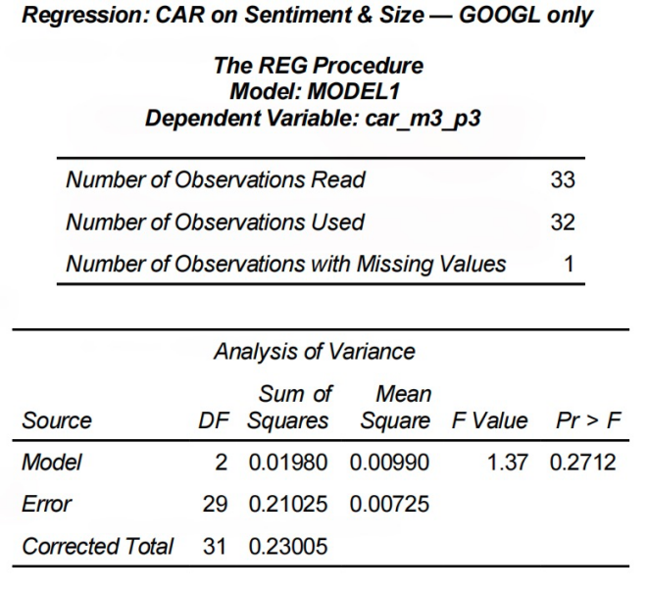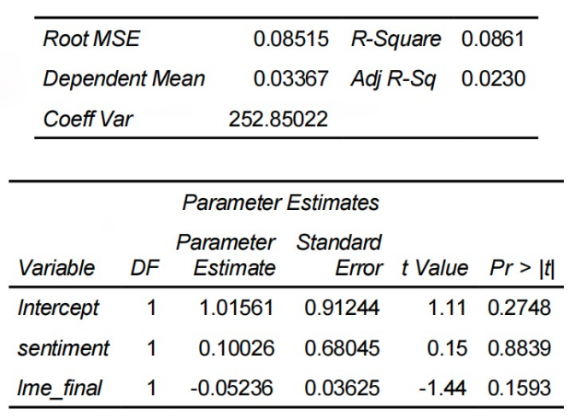
Unlike AAPL, none of the sentiment coefficients for GOOGL are statistically significant. For the (−3,+3) window, sentiment has a small and insignificant effect (0.10, p = 0.8839).
Firm size is also insignificant.
Model fit is extremely low (R² = 0.0861).
CAR(-5, +5)
Sentiment is still insignificant (0.98, p = 0.3405), and size remains insignificant.
The model explains almost none of the variation (R² = 0.0332).
CAR(-10, 10)
Again, sentiment is statistically insignificant (2.40, p = 0.2451).
Firm size also remains insignificant.
Model fit remains low (R² = 0.0566).
Conclusion for GOOGL:
Sentiment does not predict CAR in any window. This is consistent with the nature of GOOGL’s product announcements, which are generally lower-profile and generate less speculative retail-investor behavior.

Pooled Results: Sentiment and CAR
CAR(-3, +3)
Figure 4: Regression of CAR(–3,+3) on Sentiment and Size — Pooled
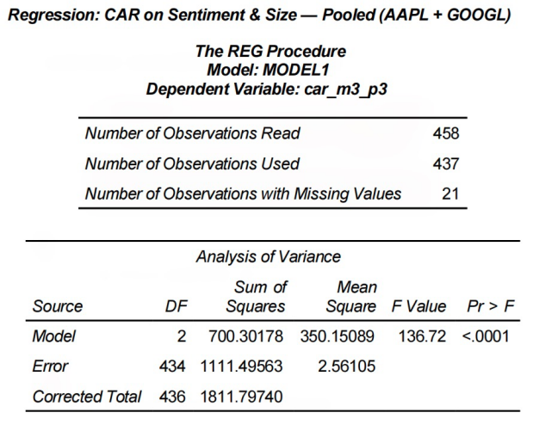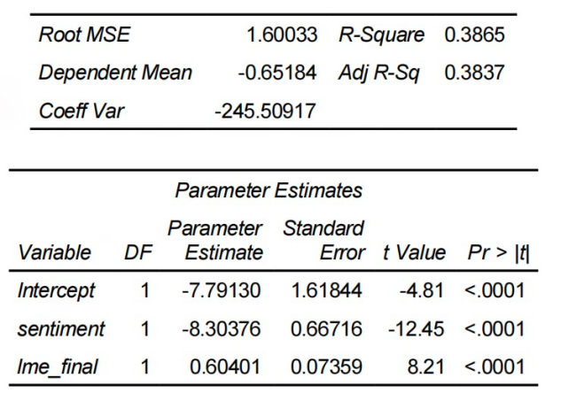
Sentiment remains strongly negative and significant: Coefficient = −8.30 (t = −12.45, p < .0001).
Firm size remains positive and significant.
Model fit remains high (R² = 0.3865).
Because GOOGL’s coefficients are insignificant and small, this pooled result is driven almost entirely by AAPL.
CAR(-5, +5)
Sentiment: Coefficient = −7.35 (p < .0001)
Firm size: 0.412 (p < .0001)
Strong model fit: R² = 0.3373
CAR(-10, 10)
Sentiment remains significant, though smaller in magnitude:
Coefficient = −1.47 (t = −3.47, p = 0.0006)
Firm size is also significant (−0.115, p = .0139).
R² is lower (0.0342).
Conclusion for Pooled Models:
Even when combining firms, sentiment remains a strong negative predictor of CAR. The pooled regressions largely mirror AAPL’s pattern, confirming that the sentiment–CAR relationship is driven almost entirely by AAPL’s event dynamics.

Sentiment Scores Distribution and Economic Magnitude
Figure 5: Sentiment Score Summary
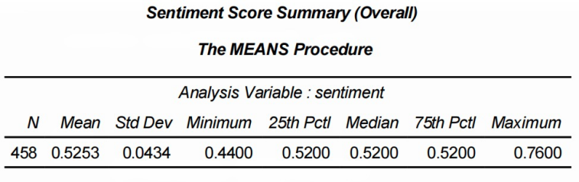
Although RavenPack sentiment scores range from –1 to +1, the smartphone–launch news in this sample is overwhelmingly positive, producing a compressed distribution. Scores cluster tightly around a mean of 0.525, with most values between roughly 0.48 and 0.58. This reflects the fact that launch announcements are typically framed as optimistic, product-focused news rather than negative coverage.
Even within this narrow range, sentiment changes have meaningful economic effects when scaled by the regression coefficients. In the pooled CAR(–3,+3) model, the sentiment coefficient is –8.30, meaning that a one–standard deviation increase in sentiment (≈ 0.043) predicts a –0.36% change in CAR. A shift from –1 to +1 sentiment would imply a –16.6% change in abnormal returns.
This shows that even small sentiment shifts matter: more positive pre-launch tone consistently predicts more negative short-term stock reactions, reinforcing a “buy-the-rumor, sell-the-news” dynamic.

Day-0 abnormal return (AR0) confirms the same pattern
To examine whether investor sentiment helps explain the immediate stock-price reaction on the exact day of a smartphone launch, I estimate a pooled cross-sectional regression of Day-0 abnormal returns (AR₀) on sentiment and firm size (log market capitalization).

Figure 6: Regression of Day-0 AR — Pooled
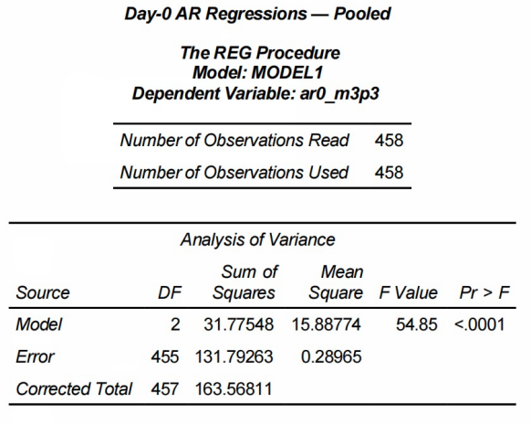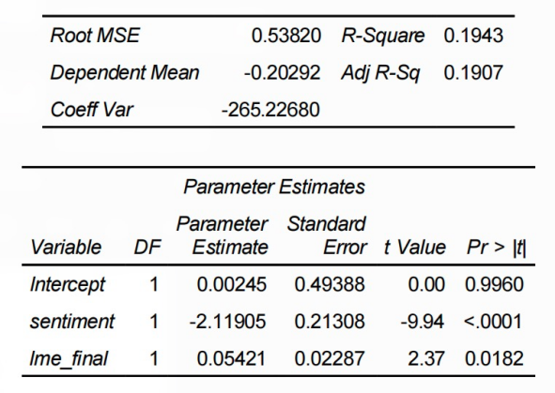
The regression shows that sentiment has a strong and statistically significant negative association with AR₀. Specifically, the coefficient on sentiment is –2.12 (t = –9.94, p < 0.0001), indicating that more positive media tone prior to the announcement predicts a more negative same-day abnormal return. This effect is substantial in magnitude and consistent with the broader “buy-the-rumor, sell-the-news” interpretation that appears in the CAR regressions.
Firm size also plays a meaningful role: the coefficient on log market cap is positive and statistically significant (0.054, p = 0.0182), implying that larger firms experience milder negative reactions on the launch day. This is consistent with the intuition that larger firms are more stable and face less volatile announcement-driven repricing.
Overall model fit is moderate (R² = 19.4%), which is high relative to typical single-day abnormal-return regressions and indicates that sentiment and size jointly account for a meaningful share of cross-sectional variation in AR₀.

Key Takeaways
- Product launches don't consistently yield positive returns for Apple or Alphabet.
- Apple’s sentiment effects are large, negative, and highly significant.
- Google shows no meaningful sentiment effects in any window.
- Pooled results are driven almost entirely by Apple.
- Short-window reactions dominate.
- Sentiment score is highly skewed but still economically powerful.
- Day-0 AR results validate the CAR patterns.

Conclusion
This study examines whether media sentiment around smartphone product launches predicts short-run stock-price reactions for Apple (AAPL) and Alphabet (GOOGL). Although average cumulative abnormal returns (CAR) across all launch events are close to zero, suggesting no systematic market-wide response, the cross-sectional results reveal a strong and asymmetric role for sentiment.
For Apple, sentiment effects are consistently large, negative, and highly significant across all event windows. More positive pre-launch tone predicts more negative abnormal returns, consistent with a “buy-the-rumor, sell-the-news” correction. These effects are strongest in the short windows and fade rapidly as the event window widens, with explanatory power falling from nearly 38% in the ±3-day window to below 3% in ±10 days. Firm size also moderates returns, with larger Apple periods experiencing smaller negative reactions.
For Google, sentiment has no predictive power in any window. Neither sentiment nor size is significant, and model fit remains extremely low, suggesting Google’s smartphone launches do not generate the same level of speculative sentiment or retail-investor trading dynamics as Apple’s product releases.
When pooling Apple and Google, the regression results mirror Apple’s patterns almost exactly—strongly negative sentiment coefficients and significant size effects—confirming that the sentiment–return relationship is driven almost entirely by Apple. Importantly, the sentiment distribution in the pooled dataset is highly compressed, with most scores clustered around a narrow positive range. Yet the economic magnitude remains substantial: even a one-standard-deviation shift in sentiment (≈0.04) corresponds to a meaningful change in CAR. This highlights that markets react not to absolute sentiment levels but to marginal deviations in tone, and that Apple’s event dynamics dominate the aggregated results.
The Day-0 abnormal return (AR₀) regressions reinforce these findings: sentiment is again strongly negative and significant, and size enters positively, confirming that the sentiment effect occurs immediately rather than over extended windows.
Overall, the results show that media sentiment influences short-run market reactions—but only for Apple and only within very narrow event windows. Apple’s uniquely visible and expectation-laden launch cycle generates sentiment-driven mispricing that subsequently corrects when the event occurs. Future work may extend this analysis to additional device manufacturers, richer sentiment sources such as social media, or alternative expected-return models to test whether similar expectation-correction dynamics arise outside Apple’s ecosystem.

